EXPT NO:6 | INTEGRATE DATA FROM VARIOUS SOURCES FOR COMPREHENSIVE ANALYSIS USING TABLEAU AND POWERBI
DATE: 24.07.2026

PRE-LAB QUESTIONS (PROVIDE BRIEF ANSWERS TO THE FOLLOWING QUESTIONS)

- What is data integration in the context of Business Intelligence (BI)?
Data integration in Business Intelligence is the process of combining data from multiple sources into a single unified dataset for analysis and reporting. It allows organizations to connect information from different systems such as CSV files Excel files and databases to create comprehensive dashboards. Integrated data provides a complete view of business performance and helps users make informed decisions by analyzing related information from multiple sources together.

- Explain the difference between a join and a data blend in Tableau.
A join combines data from two or more tables into a single table based on a common field before analysis. It works best when the datasets have related records and compatible structures. Data blending keeps datasets separate and combines them only during visualization using a common linking field. Joins generally provide better performance while data blending is useful when datasets cannot be physically combined or come from different sources.

- What are relationships and cardinality (e.g., one-to-many, many-to-many) in Power BI's data model?
Relationships in Power BI define how tables are connected through common fields such as Region or Customer ID. Cardinality describes the relationship between records in the connected tables. A one-to-many relationship means one record in one table is linked to multiple records in another table while many-to-many relationships allow multiple matching records in both tables. Correct relationships ensure accurate filtering calculations and reporting across multiple datasets.

- Why is data quality (e.g., consistent naming conventions, data types) crucial when integrating data from different sources?
Data quality is essential because incorrect data types inconsistent naming conventions and missing values can prevent successful integration between datasets. For example different spellings of region names or mismatched data types may cause relationships to fail and produce incorrect analysis. Maintaining clean and consistent data improves the reliability of reports ensures accurate calculations and helps create dashboards that reflect the true business situation for better decision making.

- Name two common challenges encountered during data integration.
Two common challenges during data integration are inconsistent data formats and missing or duplicate values. Different sources may use different naming conventions data types or measurement units which can make combining datasets difficult. Another challenge is maintaining accurate relationships between tables when common fields do not exactly match. Addressing these problems through data cleaning and validation improves the accuracy and reliability of the final integrated dashboard.

IN-LAB EXERCISE:
OBJECTIVE:
To connect to, combine, and model data from multiple disparate sources in Tableau and Power BI to create a unified, comprehensive dashboard for holistic analysis. PROCEDURE:
- Data Collection:
  - Import data from at least two different sources (e.g., a CSV file and an Excel file).
  - Dataset 1: Sales Data (CSV file) with fields like Order ID, Order Date, Region, Sales Amount.
  - Dataset 2: Regional Sales Targets (Excel file) with fields like Region, Sales Target, Target Year.
- Data Preparation and Transformation:
  - Clean both datasets: Check for inconsistencies in region names (e.g., "N. America" vs. "North America"). o Ensure data types are correct (e.g., Sales Amount is numeric, Order Date is a date).
  - Handle any missing values as appropriate.
- Data Integration and Modeling:
  - Tableau: Use the Data Source pane to establish a relationship or join between the Sales Data and Regional Targets tables using the common Region field.
  - Power BI: Use the Model view to create a relationship between the two tables, connecting them on the Region column. Define the cardinality (e.g., many-to-one).
- Create Calculated Fields for Comparison:
  - Develop new measures that leverage both datasets.
  - Examples: Target Achievement % = (SUM(Sales) / SUM(Sales Target)) * 100
  - Sales vs. Target Variance = SUM(Sales) - SUM(Sales Target)
- Design a Comprehensive Dashboard:
  - Create visuals that combine data from both sources to provide a single view of performance.
  - Add KPI cards for Total Sales and Overall Target Achievement %. o Use a gauge chart or bullet chart to show sales performance against targets for each region. o Create a combined bar chart showing Actual Sales vs. Target Sales by Region.
  - Use a map to visualize the Sales vs. Target Variance, highlighting underperforming or overperforming regions.
- Validate Data Integrity:
  - Verify that the joined/related data is accurate by cross-checking values. o Ensure filters on the dashboard correctly update visuals that use data from both sources.
- Publishing and Sharing:
  - Tableau: Publish the workbook to Tableau Public or Tableau Server.
  - Power BI: Publish the report to Power BI Service and share the link.
Experiment Datasets:
Dataset 1: Retail Sales Data (CSV) Fields Used:
- Order ID – Unique identifier for each order
- Order Date – Date of the sales transaction
- Region – Sales region
- Sales – Sales revenue from the order
Dataset 2: Regional Sales Targets (Excel) Fields Used:
- Region – Sales region (used as the key for joining/relationship)
- Sales Target – The sales goal for the region
- Target Year – The year for which the target is set

Screenshot of Tableau
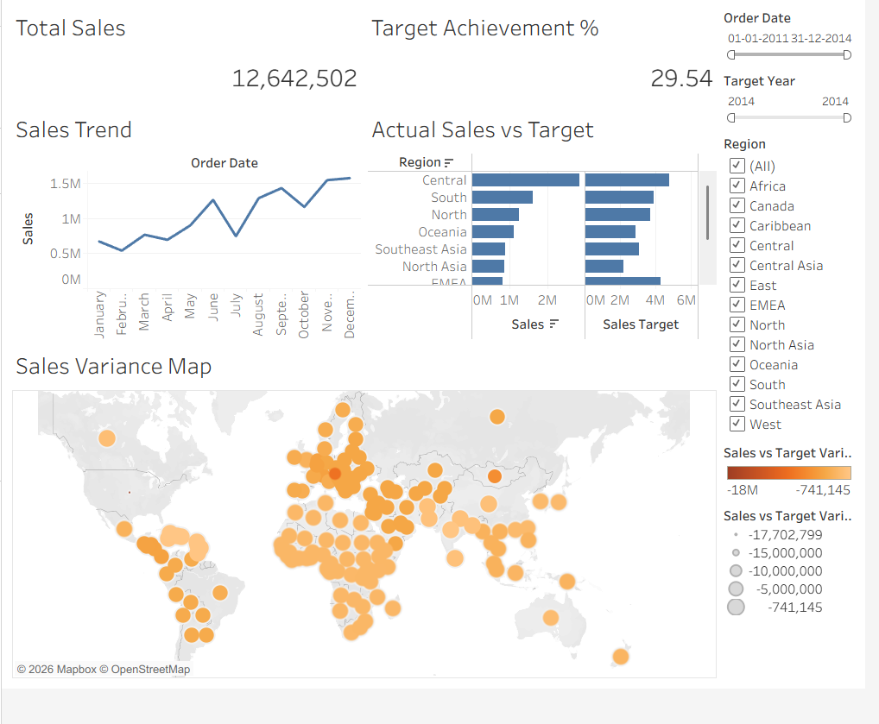
Screenshot of Power BI
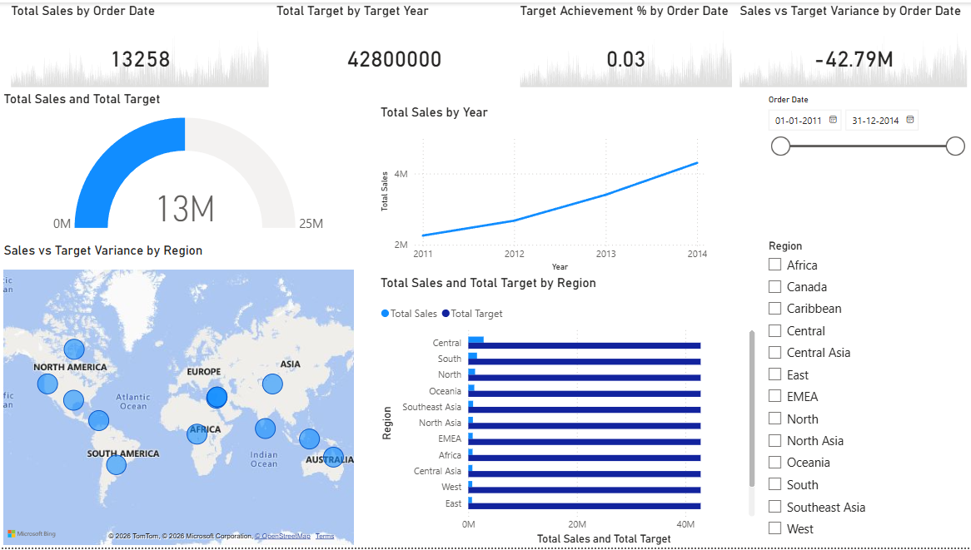
POST-LAB QUESTIONS (PROVIDE BRIEF ANSWERS TO THE FOLLOWING QUESTIONS)
- How did integrating the sales targets data provide a more complete analytical picture than using the sales data alone?
Integrating the sales targets dataset with the sales data made it possible to compare actual business performance against planned goals. Instead of viewing only sales values the dashboard also displayed target achievement percentages and sales variances for each region. This provided a more complete understanding of performance by identifying areas that exceeded expectations and regions that required improvement. The integrated analysis supported better business evaluation and decision making.

- Describe the type of join or relationship you used to combine the two datasets and explain why it was the appropriate choice.
The datasets were connected using the common Region field through a relationship in Tableau and a many-to-one relationship in Power BI. This approach was appropriate because multiple sales records belonged to a single regional sales target. The relationship preserved the original data while allowing calculations and visualizations to use information from both datasets. This ensured accurate filtering reporting and comparison between actual sales and sales targets.

- What challenges, if any, did you face regarding data granularity or mismatched keys (e.g., different region names) between the two sources?
The main challenge was ensuring that region names matched exactly in both datasets before creating the relationship. Differences in spelling formatting or capitalization could prevent records from matching correctly. Another consideration was that one dataset contained multiple sales transactions while the target dataset contained one record per region. These issues were resolved by cleaning the data and using an appropriate many-to-one relationship for accurate analysis.

- How can creating variance calculations (e.g., Sales vs. Target) help a business manager make better decisions?
Variance calculations allow business managers to compare actual sales with planned targets and identify performance gaps. Positive variance indicates that sales exceeded expectations while negative variance highlights areas requiring attention. These calculations help managers evaluate regional performance allocate resources more effectively and develop strategies to improve future sales. They also support faster decision making by presenting performance differences clearly through interactive dashboards and reports.

- What other data source (e.g., marketing campaign data, customer demographics) could you integrate to further enrich this analysis, and what new insights might it provide?
Additional datasets such as customer demographics marketing campaign results or product inventory information could further improve the analysis. Customer data would help identify buying patterns among different customer groups while marketing data would show how promotional campaigns affected regional sales performance. Inventory data could explain whether stock availability influenced sales results. Integrating these sources would provide deeper business insights and support more effective strategic planning and decision making.

RESULT:

The retail sales and regional targets datasets were successfully connected, cleaned, and integrated in both Tableau and Power BI. By creating relationships between the sources, a unified data model was built. The resulting comprehensive dashboard visualized sales performance against set targets, enabling variance analysis and providing deeper, context-rich insights into regional performance that were not possible with a single data source.

ASSESSMENT

Description |  | Max Marks | Marks Awarded
Pre Lab Exercise |  | 5
In Lab Exercise |  | 10
Post Lab Exercise |  | 5
Viva |  | 10
 | Total | 30
 | Faculty Signature

